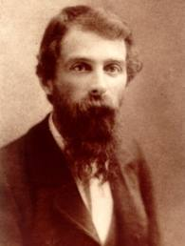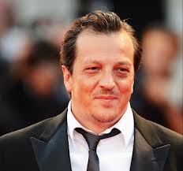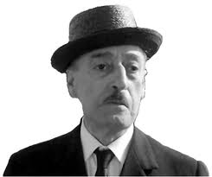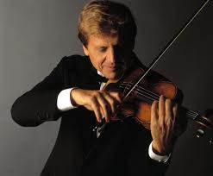 MATCH THE PHOTO TO THE CORRECT NAME

Violinist and Composer

1. Antonin Visoleji  
   **b. Uto Ughi**c. Anton Patt

d. Andrea Doria

Actor

1. **Antonio De curtis**
2. Vincenzo Salemme
3. Eduardo de Filippo
4. Peppino di Caprio

Film director

1. Cristi Puiu
2. Vittorio Gassman
3. **Gabriele Muccino**
4. Carlo Vanzina

Classic Dancer:

1. Marie Camargo
2. Anna Pavlova
3. Pierina Legnani
4. **Carla Fracci**

Painters

1. **Giuseppe pellizza da volpedo**
2. Claude monet
3. Gaugin
4. Giuseppe de nittis